import java.util.HashSet;
import java.util.Set;
class Wordinfo {
private int frequency;
private Set<Integer> lineNumbers;
public Wordinfo() {
frequency = 0;
lineNumbers = new HashSet<>();
}
public void addOccurrence(int lineNumber) {
frequency++;
lineNumbers.add(lineNumber);
}
public int getFrequency() {
return frequency;
}
public Set<Integer> getLineNumbers() {
return lineNumbers;
}
@Override
public String toString() {
return "Frequency = " + frequency +
", Lines = " + lineNumbers;
}
}
main:
import java.io.*;
import java.util.*;
class DocumentDictionary {
public static void main(String[] args) {
HashMap<String, Wordinfo> dictionary = new HashMap<>();
try {
BufferedReader br = new BufferedReader(new FileReader("src/document.txt"));
String line;
int lineNumber = 0;
while ((line = br.readLine()) != null) {
lineNumber++;
line = line.toLowerCase().replaceAll("[^a-zA-Z0-9 ]", "");
String[] words = line.split("\\s+");
for (String word : words) {
if (word.isEmpty())
continue;
dictionary.putIfAbsent(word, new Wordinfo());
dictionary.get(word).addOccurrence(lineNumber);
}
}
br.close();
System.out.println("DOCUMENT DICTIONARY");
for (Map.Entry<String, Wordinfo> entry : dictionary.entrySet()) {
System.out.println(entry.getKey() + " -> " + entry.getValue());
}
} catch (IOException e) {
System.out.println("Error: " + e.getMessage());
}
}
}

output:
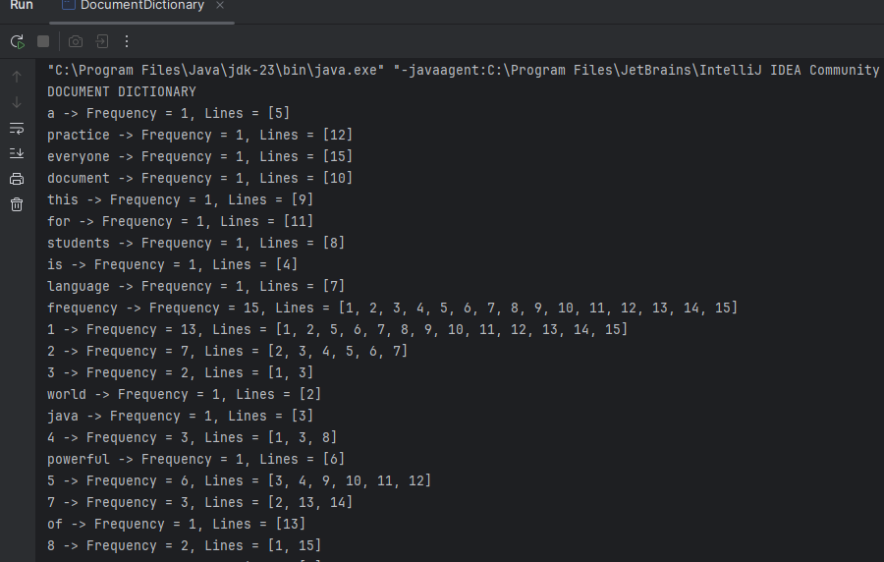

TASK2:
Product class:
import java.util.Objects;
class Product {
private int id;
private String name;
private double price;
public Product(int id, String name, double price) {
this.id = id;
this.name = name;
this.price = price;
}
public int getId() {
return id;
}
public String getName() {
return name;
}
public double getPrice() {
return price;
}
@Override
public boolean equals(Object obj) {
if (this == obj) return true;
if (!(obj instanceof Product)) return false;
Product p = (Product) obj;
return id == p.id;
}
@Override
public int hashCode() {
return Objects.hash(id);
}
}
shopping cart:
import java.util.HashMap;
import java.util.Map;
class ShoppingCart {
private HashMap<Product, Integer> cart;
public ShoppingCart() {
cart = new HashMap<>();
}
public void addProduct(Product product, int quantity) {
cart.put(product, cart.getOrDefault(product, 0) + quantity);
}
public void updateQuantity(Product product, int quantity) {
if (cart.containsKey(product)) {
cart.put(product, quantity);
}
}
public void removeProduct(Product product) {
cart.remove(product);
}
public double calculateTotalCost() {
double total = 0;
for (Map.Entry<Product, Integer> entry : cart.entrySet()) {
total += entry.getKey().getPrice() * entry.getValue();
}
return total;
}
public int totalItems() {
int total = 0;
for (int quantity : cart.values()) {
total += quantity;
}
return total;
}
public void displayCart() {
System.out.println("\nSHOPPING CART");
for (Map.Entry<Product, Integer> entry : cart.entrySet()) {
Product p = entry.getKey();
int qty = entry.getValue();
System.out.println(
p.getId() + " - " +
p.getName() +
" | Price: $" + p.getPrice() +
" | Qty: " + qty);
}
System.out.println("Total Items: " + totalItems());
System.out.println("Total Cost: $" + calculateTotalCost());
}
}

Output:
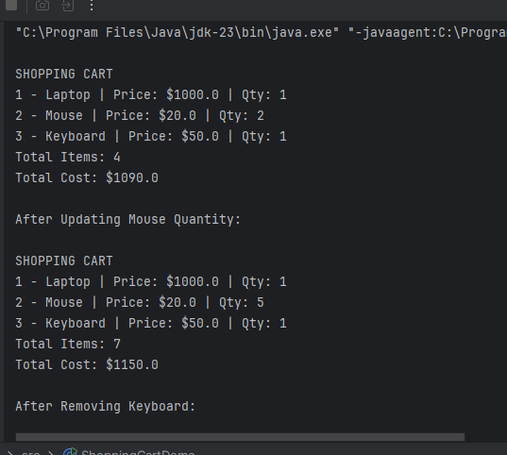

TASK3:

Hotel Room Booking System
A hotel wants to manage its room bookings using a digital system. The hotel has a limited number of rooms, each identified by a unique room number (e.g., 101, 102, 201). Customers can book a room, cancel a booking, and check the current status of all rooms.
Your job is to build a system that:
- Tracks room occupancy using a HashMap<Integer, String>, where:
Key: Room number (e.g., 101)
Value: Guest name (if booked), or null (if available)

Requirements
Feature | Description
Book a Room | Assign a guest name to a room if it's available
Cancel Booking | Remove the guest from the room
Check Availability | List all available (not booked) rooms
View Guest List | List all rooms and which guest is in which room
Search Guest | Given a guest name, find which room they're staying in

